Flight #1: Installation
Installation was done in the nosecone, the unit was wrapped with uLine Anti-static packaging foam (pink) and installed with the Terminal Block pointing down, battery (rectangular) 9.6v was below it. Antenna was installed in the bulkplate, because the RG-174 lead was too short, another RPSMA cable was used to extend the connection.
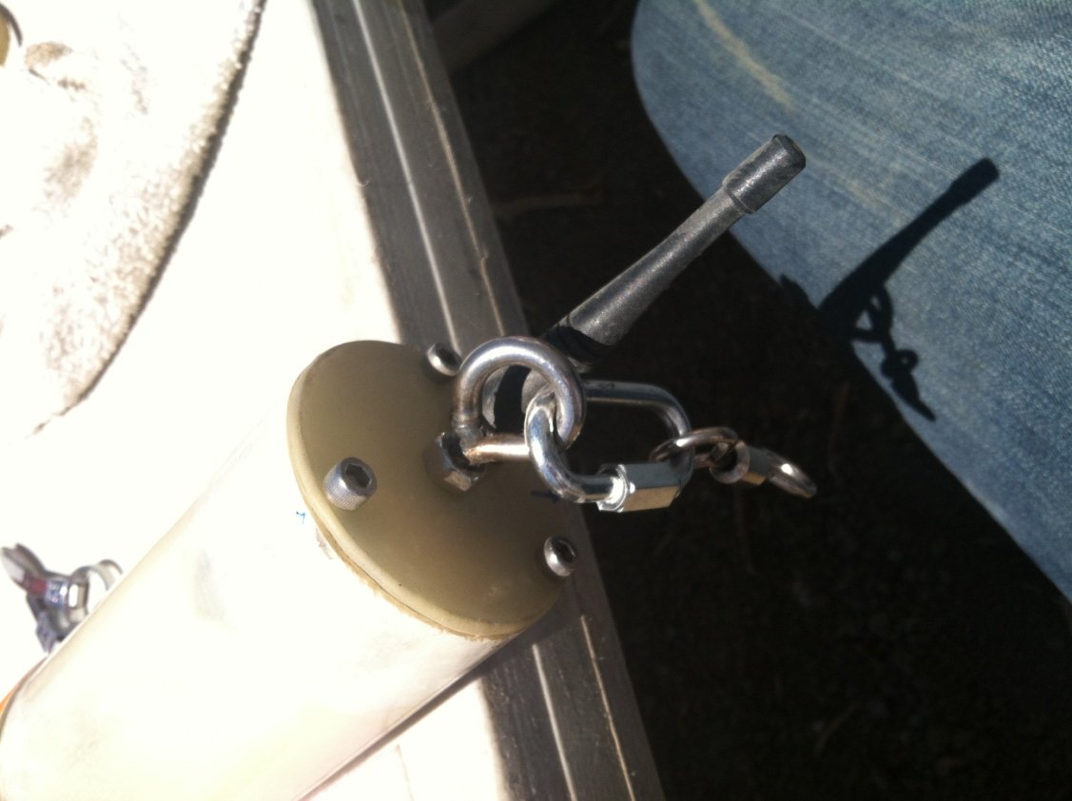

Flight #1: GPS1, Jimmy Franco, Shoot to Thrill CTI K650SS
RPSMA Straight to RPSMA RA was used as an extension cable to connect to GPS1 RF Modem and extend cable (needed longer RPSMA cable). Could have affected Antenna.
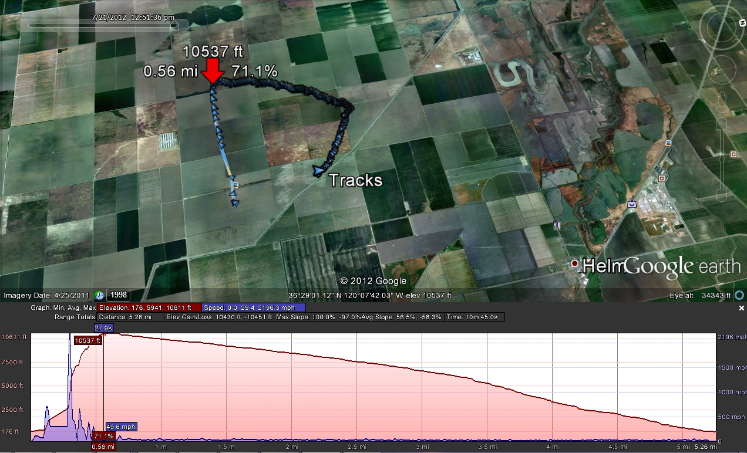
At lift-off modem lost lock. Found antenna not connected on Base!
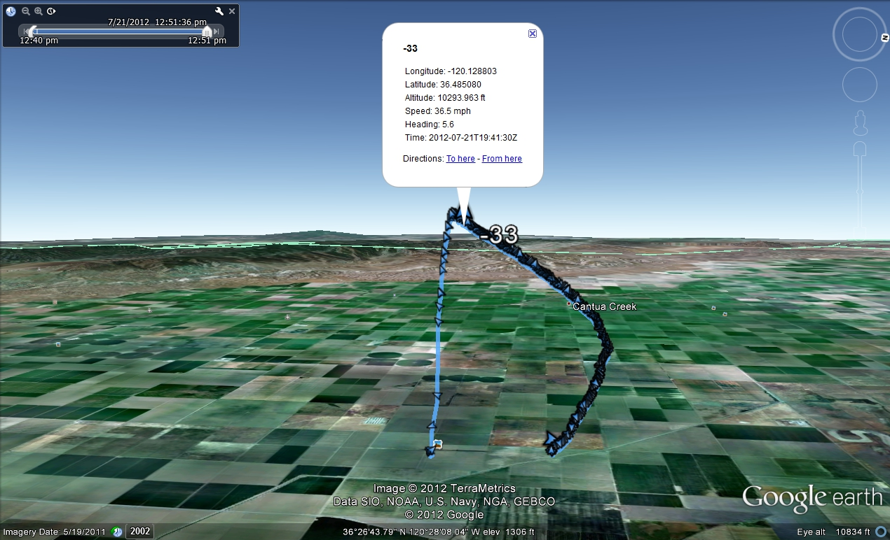

Flight #2 David Rob – L1170 Blue
Also, at liftoff, we lost lock, all systems go on the ground. This time we used a single RPSMA to 0DB antenna connection to the GPS1. After lift-off, the signal was lost. Suspect antenna is not working on GPS1 onboard RPSMA J26.
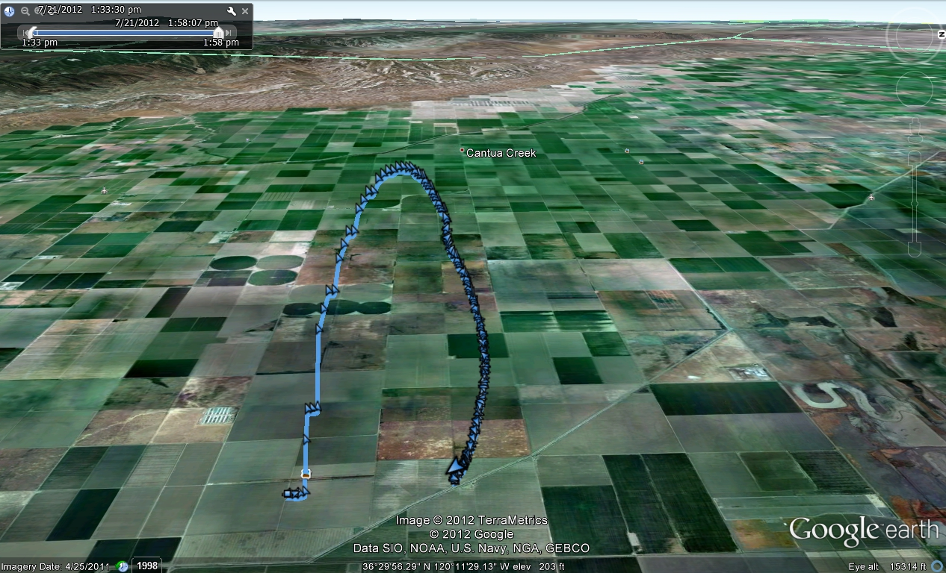

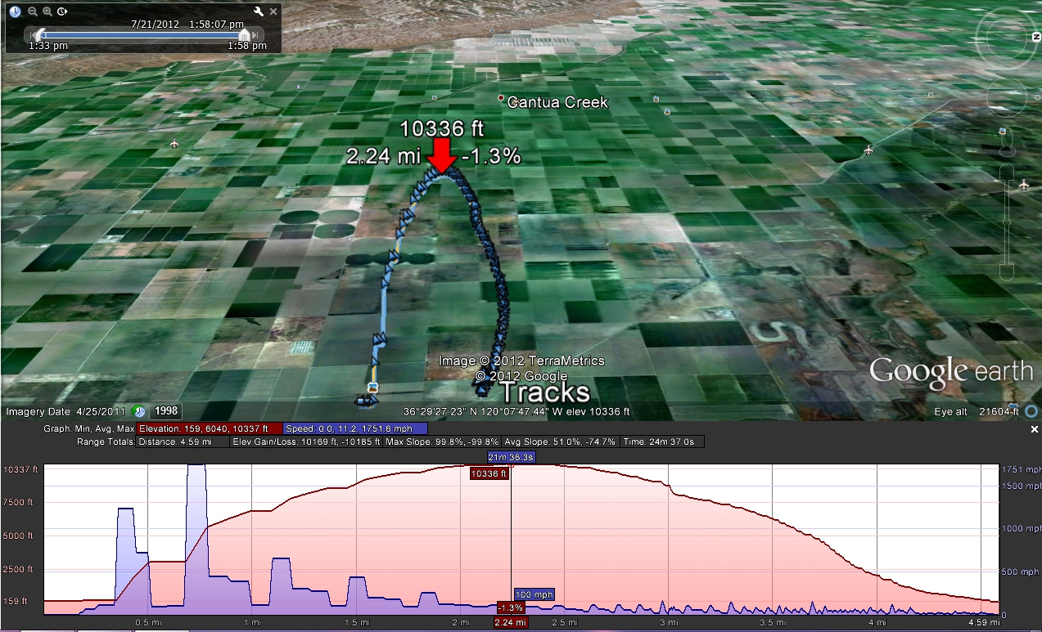

#3 Jimmy Franco – Quarter-Scale Patriot CTI-K650-Pink (new Motor)
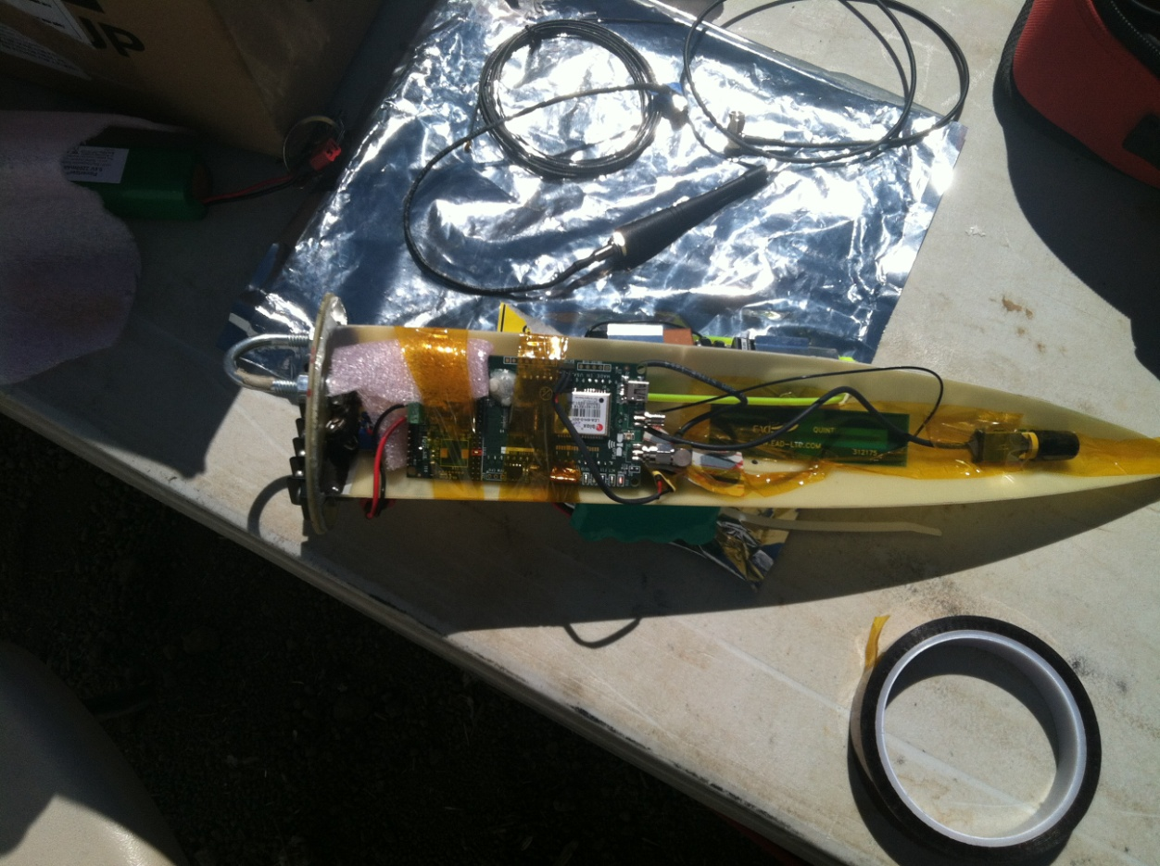
All systems go on the ground. This time we used a single uFL PCB Antenna which has a socket to connect uFL on the modem module itself. Lock was good, we lost it at lift-off. Suspect that we have a short. Checked the base-station and found the antenna was not connected (cable lead is gnarled). Replaced 8dB patch antenna during flight and got lock a few times in mid-air. Good thing we did, since we wouldn’t have recovered the module otherwise.

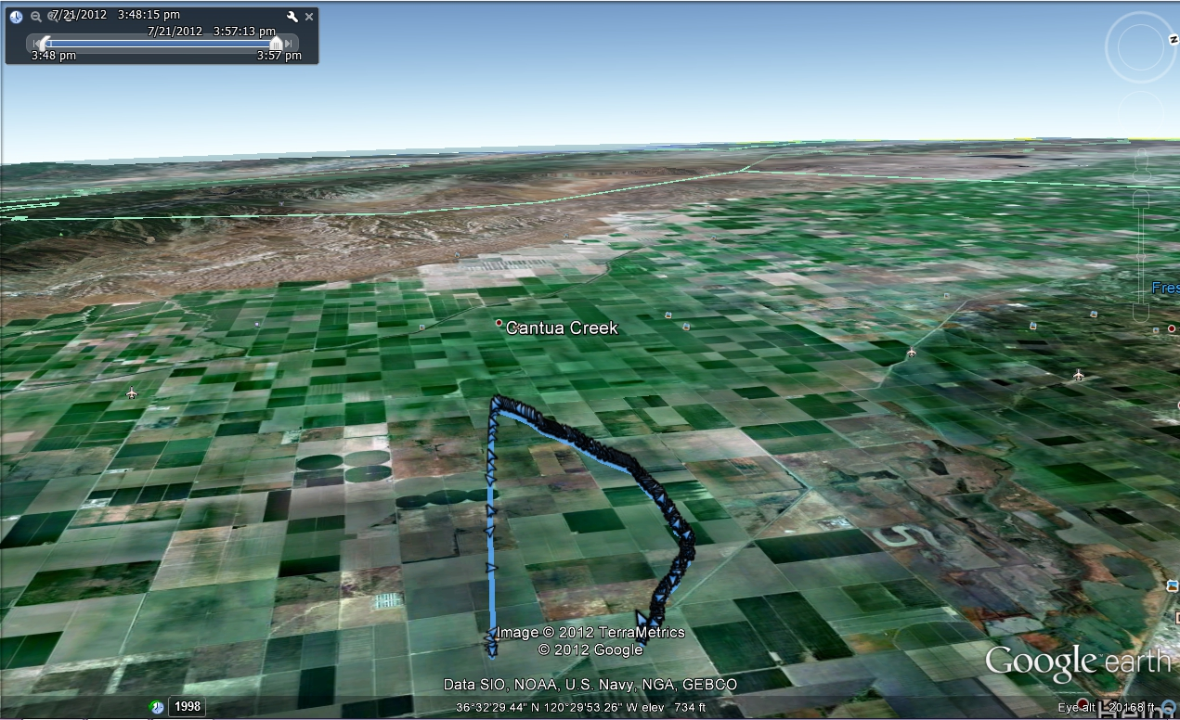
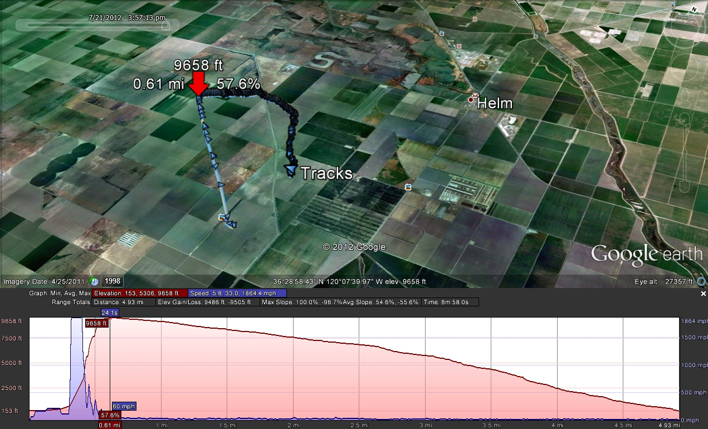

At time t=4425 seconds (GPS battery jumps from .58 to .74v). At time t=5241 seconds (Main battery drops from 10.49v to 1.62v). At time t=7016 (Main battery drops to 0 volts)

The GPS Battery cell looks like it became disconnected around apogee:

RF performance suffered and we didn’t receive lock until we were about 1900’ from the vehicle again on the ground.

Temperature onboard was very high, glitches co-incide with voltage drops and shorted power pin.

Inspection in post-flight showed the failure mode: The power pin for one of the test headers shorted 3.3v to ground! Probably this happened at Apogee but we cannot correlate the flight data from the altimeter which was used onboard.
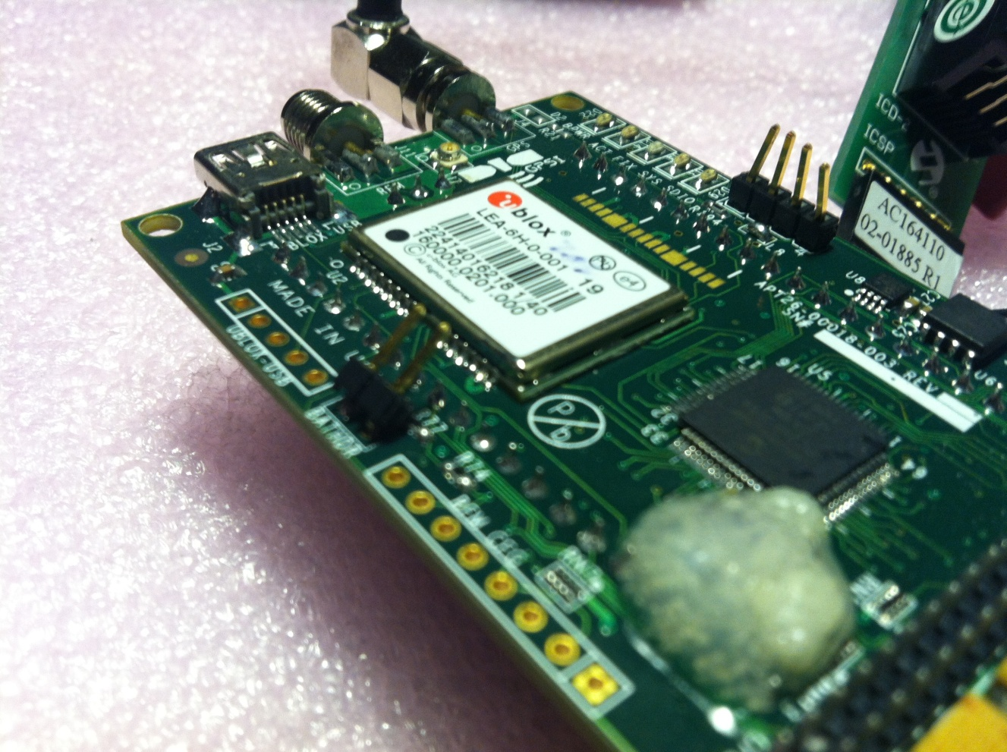

Note the GPS battery pin was bent, we also found the 2-pin header disconnected and broken lead on one end of the wire.

Considering the nosecone could have smasked the airframed during deployment, this is the most likely scenario.

Failure Analysis

Both the initial flight and the last flight shorted the power pins to the I2C debug header, this caused a short and subsequent ability for the RF Modem to transmit at any range. During the final moments of the flight, a bad antenna cable was found on the Base-station itself! Finding this luckily the vehicle was in the air long enough to catch the position when the antenna was replaced! The second flight did not have any lock as soon as the vehicle took off since the Base-station antenna was later found to have a faulty RPSMA connector!

Flight 1: Failures
- Shorted I2C-LCD and GPS Battery pins
- RPSMA RF Antenna – Impedance ruined with double RPSMA Cable
- Base-Station had bad antenna leads

Flight 2: Failures
- DNT900P – RPSMA on PCB with 3-pin headers

Flight 3: Failures
- Shorted I2C-LCD and GPS Battery pins
- uFL Antenna connection from DNT900P to PCB (3db) Antenna (Pentaband)
- Base-Station had bad antenna leads
- Recovered lock when swapped 8dB Patch antenna with 3dB Whip (Rubber Duck) Antenna

Flight Statistics

Summary | Boot | Lift-Off (7/21/12) | Apogee | Touchdown | Shutdown
K650SS | 11:55:27 AM | 12:40:54 PM | 12:41:21 PM | 12:49:01 PM | 1:22:54 PM
L1170B | 1:33:24 PM | 1:54:40 PM | 1:55:09 PM | 1:58:32 PM | 2:23:03 PM
K650P | 3:28:29 PM | 3:48:11 PM | 3:48:40 PM | 3:57:31 PM | 4:42:33 PM

Summary | Runtime (hh:mm) | FlightTime | Recovery Time
K650SS | 1:27 | 0:08 | 0:33
L1170B | 0:49 | 0:03 | 0:24
K650P | 1:14 | 0:09 | 0:45

Summary | Altitude | Distance | AGL | Altitude (AGL)
K650SS | 10,612.53 | 5.32mi | 171 | 10,441.53
L1170B | 10,299.21 | 4.58mi | 175.85 | 10,123.36
K650P | 9,634.19 | 5.01 mi | 170.93 | 9,463.26

Summary
- The PCB should ALWAYS be mounted for best results, wrapping the unit in rubber foam ONLY worked for the 2nd flight (as evidence shows from the battery plot) however this could have failed the same way from the shorted I2C/Power header.
- Both the Base-station antenna and RF antenna need to be checked before flying, packing everything in and giving it a ground test should require the vehicle to be moved an appreciable distance (1/4 mile) for verification that the antenna is visible and no shorts in the system.
- RF Testing needs to be done with DNT900P uFL connection to Antenna as well as RPSMA connection to antenna (Rate versus range)
  - DNT900P – RPSMA on PCB with 3-pin headers RF ok?
  - uFL from Modem to uFL to RPSMA, better RF?
- 1uF capacitor used for AD8211, requiring a multiplier of 10, whereas 10uF capacitor only required a multiplier of 1.
- Temperature testing needs to be done with RF testing, operation above 170F and above (80C should be expected). Consequently, only industrial or military grade components should be used.
- Suggest JTEC socket connectors for Battery header (pins on the edge of the board can short or create form factor issues)
- Suggest JTEC socket connector for ICSP header
- Do not populated I2C-LCD header on remote!

